B.S.C.C. The Bishop’s Stortford Chess Club
Parking & New Venue
Jackson Square Car Park  Access by car is only from the A1250 NW bound.  Methodist Church Hall  On the West side,  just beyond Tescos Express |  |  | Bishops Stortford  Whether coming from the A120 in the West or from the M11 junction to the East, you will end up on the 1 way system of the A1250.  Don’t panic!  Both ends are buffered with roundabouts. If you go wrong, just keep going round and start again.
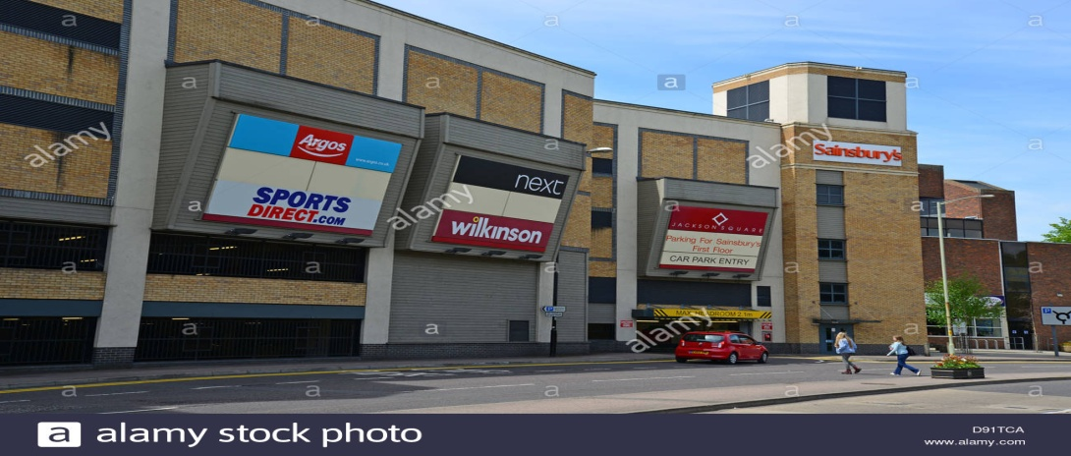  Jackson Square Car Park  This is the only entrance by car. |  |  | Jackson Square Car Park  View from A1250.  There is a slip road just before it. Use this and access.  Stay on the ground level.  Park somewhere in the middle.  This is free after 6:30pm and open 24hrs.
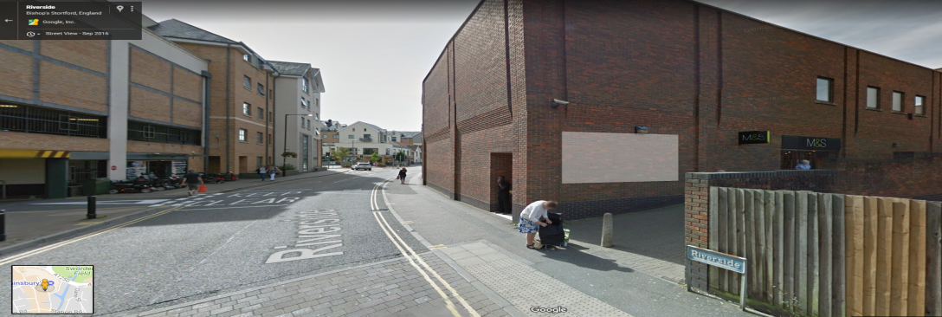  Take the footpath to side of M&S  This is the back of the car park |  |  | Walking  When leaving the car, walk in the opposite direction to the car park entrance.  Vacate the car park and the building at the back, cross the road.  There is a footpath running between the shops (M&S on the left)  Take this and head straight on to South Street.
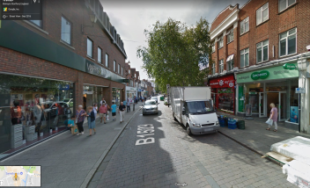 | 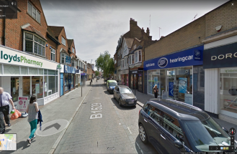 | 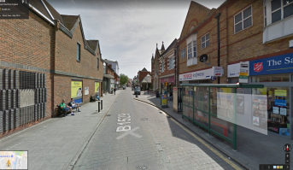 | Turn left and walk down South Street.  You will pass: M&S / Boots / Elements / Poundland / Tesco Express.  The Church is on the right just beyond.
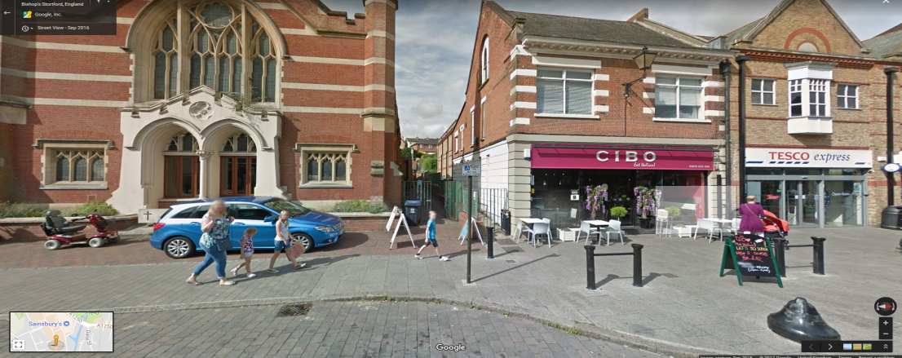  Methodist Church  Metal gate & Alley to rear access and new venue. |  |  | New Venue  When facing the church you will find a gated entrance to the right side. Go through; follow the pathway to the side of the church until you get to the double door rear entrance.  Go in and follow the corridor to the right. The club room is to the right

